

**Project on Cisco Packet Tracer**

|  |  |
| --- | --- |
| Submitted to -  **Azim Uddin Chowdhury**  Project Coordinator & Instructor (CCAI),  Cisco Networking Academy & CSE Department,  United International University | Submitted by -  Name: **Md. Shakhan**  ID:**011201301**  Section: D  Course Code: CSE 324/CSE 3712 |

**Network Diagram Design on PT**

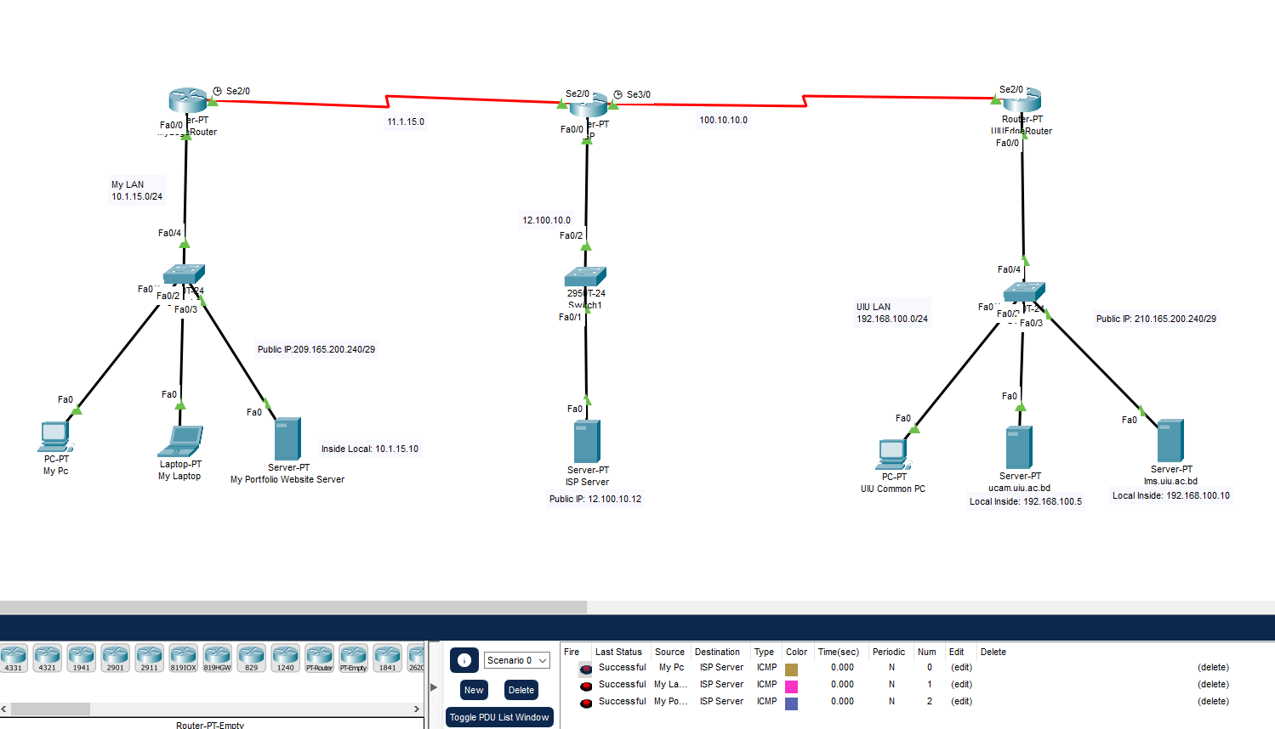

**Ping UIU Network with ISP:**

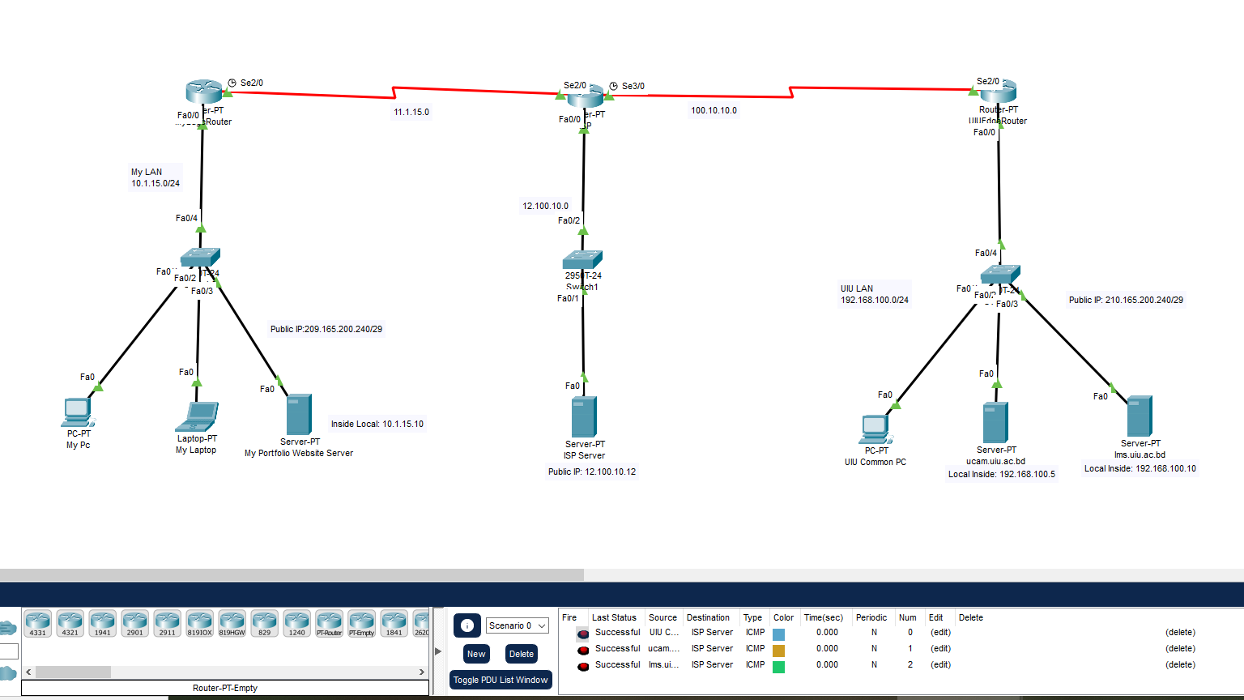

**Code:**

**1. Hostname Change**

**MyEdgeRouter:**

Router>en

Router#conf t

Enter configuration commands, one per line. End with CNTL/Z.

Router(config)#hostname MyEdgeRouter

MyEdgeRouter(config)#

**ISP:**

Router>en

Router#conf t

Enter configuration commands, one per line. End with CNTL/Z.

Router(config)#hostname ISP

ISP(config)#

**UIUEdgeRouter:**

Router>en

Router#conf t

Enter configuration commands, one per line. End with CNTL/Z.

Router(config)#hostname UIUEdgeRouter

UIUEdgeRouter(config)#

**2. IP Configaration**

**MyEdgeRouter:**

MyEdgeRouter(config)#

MyEdgeRouter(config)#int f0/0

MyEdgeRouter(config-if)#ip add

MyEdgeRouter(config-if)#ip address 10.1.15.1 255.255.255.0

MyEdgeRouter(config-if)#no sh

MyEdgeRouter(config-if)#no shutdown

MyEdgeRouter(config-if)#

%LINK-5-CHANGED: Interface FastEthernet0/0, changed state to up

%LINEPROTO-5-UPDOWN: Line protocol on Interface FastEthernet0/0, changed state to up

MyEdgeRouter(config-if)#exit

MyEdgeRouter(config)#

MyEdgeRouter(config)#int se2/0

MyEdgeRouter(config-if)#ip add

MyEdgeRouter(config-if)#ip address 11.1.15.1 255.255.255.0

MyEdgeRouter(config-if)#no sh

%LINK-5-CHANGED: Interface Serial2/0, changed state to down

MyEdgeRouter(config-if)#exit

**ISP:**

ISP(config)#

ISP(config)#int f0/0

ISP(config-if)#ip add 12.100.10.10 255.255.255.0

ISP(config-if)#no sh

ISP(config-if)#

%LINK-5-CHANGED: Interface FastEthernet0/0, changed state to up

%LINEPROTO-5-UPDOWN: Line protocol on Interface FastEthernet0/0, changed state to up

ISP(config-if)#exit

ISP(config)#

ISP(config)#

ISP(config)#int s2/0

ISP(config-if)#ip add 11.1.15.2 255.255.255.0

ISP(config-if)#no sh

ISP(config-if)#

%LINK-5-CHANGED: Interface Serial2/0, changed state to up

ISP(config-if)#exit

ISP(config)#

ISP(config)#

ISP(config)#int s3/0

ISP(config-if)#ip add 100.10.10.1 255.255.255.0

ISP(config-if)#no sh

%LINK-5-CHANGED: Interface Serial3/0, changed state to down

ISP(config-if)#exit

**UIUEdgeRouter:**

UIUEdgeRouter>en

UIUEdgeRouter#conf t

Enter configuration commands, one per line. End with CNTL/Z.

UIUEdgeRouter(config)#int f0/0

UIUEdgeRouter(config-if)#ip add 192.168.100.1 255.255.255.0

UIUEdgeRouter(config-if)#no sh

UIUEdgeRouter(config-if)#

%LINK-5-CHANGED: Interface FastEthernet0/0, changed state to up

%LINEPROTO-5-UPDOWN: Line protocol on Interface FastEthernet0/0, changed state to up

UIUEdgeRouter(config-if)#exit

UIUEdgeRouter(config)#

UIUEdgeRouter(config)#int s2/0

UIUEdgeRouter(config-if)#ip add 100.10.10.2 255.255.255.0

UIUEdgeRouter(config-if)#no sh

UIUEdgeRouter(config-if)#

%LINK-5-CHANGED: Interface Serial2/0, changed state to up

UIUEdgeRouter(config-if)#e

%LINEPROTO-5-UPDOWN: Line protocol on Interface Serial2/0, changed state to up

% Ambiguous command: "e"

UIUEdgeRouter(config-if)#

UIUEdgeRouter(config-if)#exit

UIUEdgeRouter(config)#

**3.DHCP Configure**

**MyEdgeRouter:**

MyEdgeRouter>en

MyEdgeRouter#conf t

Enter configuration commands, one per line. End with CNTL/Z.

MyEdgeRouter(config)#ip dhcp pool MyEdgeRouterF0/0

MyEdgeRouter(dhcp-config)#network 10.1.15.0 255.255.255.0

MyEdgeRouter(dhcp-config)#default

MyEdgeRouter(dhcp-config)#default-router 10.1.15.1

MyEdgeRouter(dhcp-config)#dns

MyEdgeRouter(dhcp-config)#dns-server 8.8.8.8

MyEdgeRouter(dhcp-config)#exit

MyEdgeRouter(config)#ip dhcp ex

MyEdgeRouter(config)#ip dhcp excluded-address 10.1.15.1 10.1.15.20

MyEdgeRouter(config)#

MyEdgeRouter(config)#

**UIUEdgeRouter:**

UIUEdgeRouter>

UIUEdgeRouter>en

UIUEdgeRouter#conf t

Enter configuration commands, one per line. End with CNTL/Z.

UIUEdgeRouter(config)#ip dhcp pool UIUEdgeRouterF0/0

UIUEdgeRouter(dhcp-config)#network 192.168.100.0 255.255.255.0

UIUEdgeRouter(dhcp-config)#default-router 192.168.100.1

UIUEdgeRouter(dhcp-config)#dns-server 8.8.8.8

UIUEdgeRouter(dhcp-config)#exit

UIUEdgeRouter(config)#ip dhcp excluded-address 192.168.100.1 192.168.100.20

UIUEdgeRouter(config)#

**4. Configure Routing Protocols**

**MyEdgeRouter:**

MyEdgeRouter>en

MyEdgeRouter#conf t

Enter configuration commands, one per line. End with CNTL/Z.

MyEdgeRouter(config)#router rip

MyEdgeRouter(config-router)#net 10.1.15.0

MyEdgeRouter(config-router)#net 11.1.15.0

MyEdgeRouter(config-router)#exit

MyEdgeRouter(config)#ip route 0.0.0.0 0.0.0.0 11.1.15.2

MyEdgeRouter(config)#router rip

MyEdgeRouter(config-router)# default-information originate

**UIUEdgeRouter:**

UIUEdgeRouter>en

UIUEdgeRouter#conf t

Enter configuration commands, one per line. End with CNTL/Z.

UIUEdgeRouter(config)#router rip

UIUEdgeRouter(config-router)#net 100.10.10.0

UIUEdgeRouter(config-router)#net 192.168.10.0

UIUEdgeRouter(config-router)#

UIUEdgeRouter(config-router)#ex

UIUEdgeRouter(config)#ip route 0.0.0.0 0.0.0.0 100.10.10.1

UIUEdgeRouter(config)#router rip

UIUEdgeRouter(config-router)# default-information originate

**ISP:**

ISP>en

ISP#conf t

Enter configuration commands, one per line. End with CNTL/Z.

ISP(config)#ip route 209.165.200.240 255.255.255.248 11.1.15.1

ISP(config)#ip route 210.165.200.240 255.255.255.248 100.10.10.2

**5. Configure NAT**

**MyEdgeRouter:**

MyEdgeRouter(config)#

MyEdgeRouter(config)#

MyEdgeRouter(config)#

MyEdgeRouter(config)#ip nat inside source static 10.1.15.10 209.165.200.241

MyEdgeRouter(config)#access-list 1 permit 10.1.15.0 0.0.0.255

MyEdgeRouter(config)#ip nat pool NAT-POOL 209.165.200.242 209.165.200.244 netmask 255.255.255.248

MyEdgeRouter(config)#ip nat inside source list 1 pool NAT-POOL overload

MyEdgeRouter(config)#int s2/0

MyEdgeRouter(config-if)#ip nat outside

MyEdgeRouter(config-if)#exit

MyEdgeRouter(config)#int f0/0

MyEdgeRouter(config-if)#ip nat inside

MyEdgeRouter(config-if)#exit

MyEdgeRouter(config)#

MyEdgeRouter(config)#

**UIUEdgeRouter:**

UIUEdgeRouter(config)#

UIUEdgeRouter(config)#ip nat inside source static 192.168.100.5 210.165.200.241

UIUEdgeRouter(config)#ip nat inside source static 192.168.100.10 210.165.200.242

UIUEdgeRouter(config)#access-list 2 permit 192.168.100.0 0.0.0.255

UIUEdgeRouter(config)#ip nat pool NAT-POOL 210.165.200.243 210.165.200.244 netmask 255.255.255.248

UIUEdgeRouter(config)#ip nat inside source list 2 pool NAT-POOL overload

UIUEdgeRouter(config)#int s2/0

UIUEdgeRouter(config-if)#ip nat outside

UIUEdgeRouter(config-if)#exit

UIUEdgeRouter(config)#int f0/0

UIUEdgeRouter(config-if)#ip nat inside

UIUEdgeRouter(config-if)#exit

UIUEdgeRouter(config)#